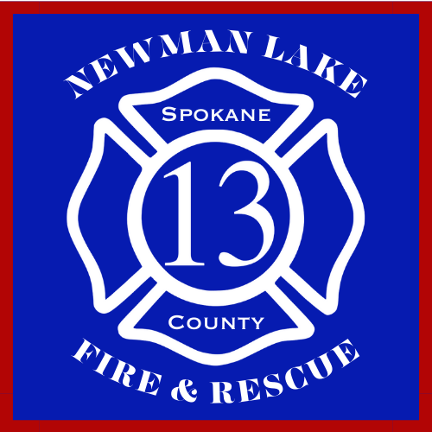
NEWMAN LAKE FIRE & RESCUE
SPOKANE COUNTY FIRE DISTRICT 13

MEMBERSHIP APPLICATION

Date:

Name:
Last First Middle
Have you ever been known by any other name? If yes, list:

Last First Middle
Physical Address:
Street City State/Zip
Mailing Address:
Street City State/Zip
Telephone: ___________________ Cell: ________________ E-mail:
Driver’s License #: Years of Driving Experience:
Position Applied For: ___Community Volunteer ___Resident Volunteer ___Shift Volunteer
Type of Volunteer: ___Firefighter ___EMT ___Both ___Maintenance Other
Have you submitted an application here before? _______________ When:
Name of Employer: ___________________________________ Phone Number: _________________
May we contact you at work? __________________ Best time to call: _________________________
List any previous volunteer work and your responsibilities: __________________________________
__________________________________________________________________________________
__________________________________________________________________________________
Are you at least 18 years old? Would you submit to a drug test? _____ _____
Will you provide proof of Covid-19 vaccination?
Have you ever been convicted of a felony? __________________
Have you had any driving offenses/DWI’s in the past five (5) years? ___________________________
If yes to any offenses, please provide dates and details on a separate page.

Membership Application (continued)

List last two (2) schools attended, number of years completed, and what degree/diploma earned:
__________________________________________________________________________________
__________________________________________________________________________________
List name and telephone number of three (3) references who are NOT related to you:
__________________________________________________________________________________
__________________________________________________________________________________
__________________________________________________________________________________
List any additional information you would like us to consider including any special skills/training that would qualify you for the position for which you are applying:
__________________________________________________________________________________
__________________________________________________________________________________

I declare that all statements regarding this application to be true, complete, and correct.

I expressly authorize, without reservation, Spokane County Fire District #13 to contact and obtain information from all references, employers, public agencies, licensing authorities, police departments and educational institutions to verify the accuracy of all information on this application.

I understand that any information found to be false, incomplete, or misrepresented in any respect will be sufficient cause to cancel further consideration of the application or justification for termination from SCFD13.

Date: _________________ Signature: __________________________________________________

Department Use Only

Proposed By: _________________________________________

Approved By Date: __________________

Date: __________________

Date: __________________

Chief or Designee Approval: Date:

