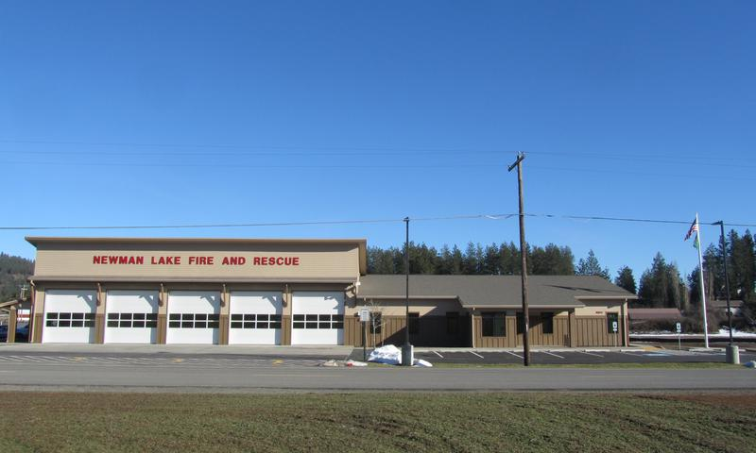

**RESIDENT FIREFIGHTER PROGRAM**

**NEWMAN LAKE FIRE & RESCUE**

**Spokane County Fire District #13**

Spokane County Fire District #13 is now accepting applications for the Resident Firefighter Program. The intent of this program is to provide experience, opportunity and training to qualified individuals interested in pursuing a career in the fire service.

Resident firefighters accepted into this program will be provided with living accommodations. In return, the firefighter will be required to fill the following each month:

* 1. 8 weeknight shifts (9pm-6am)
  2. One 48-hour weekend shift (6am Saturday – 6am Monday)

**BENEFITS**

* Private sleeping quarter with common kitchen, bathroom, dayroom, laundry, and weight room
* Alarm response and firefighter duty assignment experience
* Continuing educational opportunities
* Uniform and required protective equipment needed to perform duties.

**REQUIREMENTS**

* Must be 18 years of age.
* Must have a current Washington State EMT certification.
* Must have Firefighter 1 or equivalent training within the last 2 years.
* Possess a valid Washington State driver’s license, an acceptable driving record, and at least 2 years of driving experience.
* Successfully pass a physical exam, including drug test and pulmonary test.
* Successfully pass a background investigation.
* Physically and mentally capable of performing the function of a Firefighter/EMT.

**APPLICATION PROCESS**

* Application can be obtained at Newman Lake Fire & Rescue Station #1: 9324 N Starr Rd, Newman Lake, WA 99025. Monday – Thursday 10am – 4pm or call 509-226-1482.
* Return completed application with letter of interest to Newman Lake Fire & Rescue,

PO Box 70, Newman Lake, WA 99025.

If you have any questions, please contact Newman Lake Fire & Rescue at (509)226-1482

or by email at brisa@newmanlakefire.net.