SPOKANE COUNTY FIRE DISTRICT NO. 13
Newman Lake Fire & Rescue

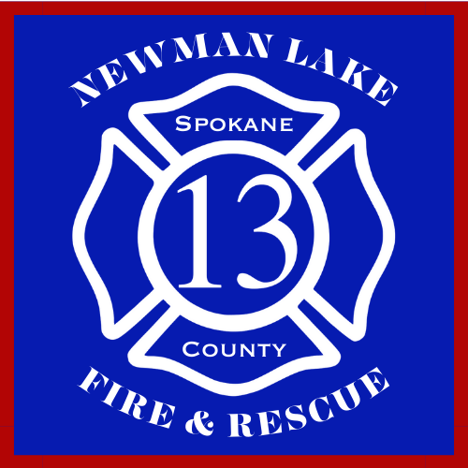

November 13, 2023

PUBLIC BUDGET HEARING MEETING 6:00 PM

STATION 1
9324 N. Starr Road
NEWMAN LAKE, WA 99025

Participate remotely via GoToMeeting
Call in to participate: 1 (224) 501-3412
Meeting Number: 442-130-453

